Access Your Class
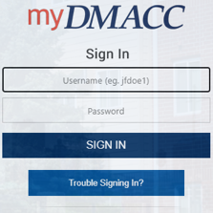
- Go to the DMACC homepage at www.dmacc.edu.
- Click the myDMACC button at the top and sign in.
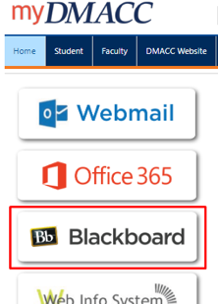
  - Your username is your DMACC email address without @dmacc.edu.
  - If you need help resetting your password, submit a Tech Support ticket or click the Trouble Signing In button.
- After you are logged into myDMACC, click on the Blackboard button on the left.
- Blackboard will open in a new browser tab.
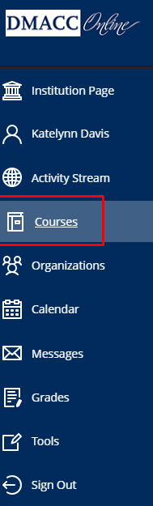
- In the menu on the left, select Courses.
- A list of all your courses will appear. Click on the name of the course you wish to enter.
  - Courses will automatically appear in a list format. You can adjust this view by changing from the list icon to grid icon.
  - You can “favorite” courses you want to appear at the top of your list by selecting the star to the right of the course name.
  - You can also filter your courses by term by clicking the “Current Courses” menu at the top.
If your course has a virtual meeting in Blackboard Collaborate, visit the Blackboard Collaborate Ultra Help Guide for Students for more information.
Click on the Blackboard Basics for Students course in your Courses list for additional Blackboard information, resources, and to practice using some of the Blackboard tools.

